**Data Manipulation and Cleaning work**

**Green – task given by client (question)**

**Blue – what I have done (for explanation purpose)**

**Account Table**

1. Convert the Date attribute into a yyyy-mm-dd by adding 23 in year format in Excel or SQL

* 1993 = 2016
* 1994 = 2017
* 1995 = 2018
* 1996 = 2019
* 1997 = 2020

1. =date(left(a1,2)+23,mid(a1,3,2),right(a1,2)).
2. (OR) IF(LEFT(A1,2) =”93”,”2016”,IF(LEFT(A1,2)=”94”,”2017”, IF(LEFT(A1,2)=”95”,”2018”, IF(LEFT(A1,2)=”96”,”2019”, IF(LEFT(A1,2)=”97”,”2020”,”unknown”)))))&”-“&Mind(A1,3,2)&”-“&RIGHT(a1,2)

(SQL :- Date_add(“940612”, Interval 23 Year).)

1. Replace in frequency attribute “POPLATEK MESICNE” AS Monthly issuance, “POPLATEKTYDNE” AS weekly issuance, and “POPLATEK POBRATU” AS issuance after a transaction in Excel or create a case statement in SQL.
2. Create a Custom Column Card_Assigned and assign below :

* Silver -> Monthly issuance
* Diamond - weekly issuance
* Gold - Issuance after a transaction

**CARD Table**

1. Replace type attribute value “junior” as Sliver, “Classic” as Gold,

And “Gold” as Diamond by using replace in Excel or by using update in SQL.

1. Convert issued attribute into yyyy-mm-dd adding 23 in year.

**CLIENT Table**

1. Convert bith_number attribute to yyyy-mm-dd format(add 23 to the year) and also create another column named sex by applying in birth_number 0 for females and 1 for males.

For **Male** its in **YYMMDD** format and for female it is **YYMM+50DD** for **Women**

1. (=if(mod(bith_number,2)=0, “Female”, “Male”) in excel or using case statement in SQL. [That’s from client side and a way to make it a confidential whose male or whose female]
2. =date(left(a1,2)+23,mid(a1,3,2),right(a1,2)). [Just life account table we need to correct our date]

**DISTRICT Table**

1. Change all column names and delete the attributes a12 and a 13

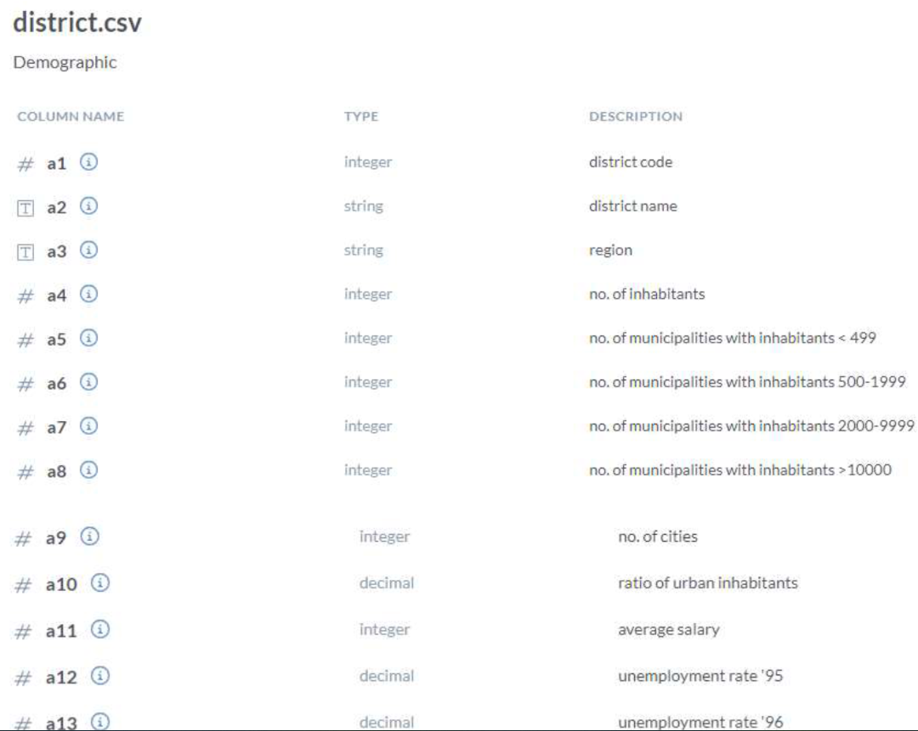

**LOAN Table**

1. Convert the Date Attribute into yyyy-mm-dd format adding 23 in year.
2. Convert Status Attribute value “A” as Contract Finished, “B” as Loan Not Paid, “C” as Running Contract, and “D” Client in debt.

**Transactions Table**

In the Transactions Table do the following , whosoever count is highest sort it in descending order and change the year from 2022,2021,2020 and so on

--DATA TRANSFORMATION (CLIENT REQUIREMENT)

BY MISTAKE THEY PUT WRONG YEAR IN DATE

/*

2021 -> 2022

2020 -> 2021

2019 -> 2020

2018 -> 2019

2017 -> 2018

2016 -> 2017 */

REPLACE NULL BANK YEAR WISE TO A SPECIFIC BANK NAME GIVEN BELOW.

/*

2022= 'Sky Bank'

2021= 'DBS Bank'

2019 = 'Northern Bank'

2018 = 'Southern Bank'

*/

**SQL :-**

**ANSWER:-**

UPDATE DATE :-

SELECT REPLACE(`DATE`,2021,2022) FROM TRANSACTIONS

UPDATE TRANSACTIONS

SET `DATE` = REPLACE(`DATE`,2021,2022)

UPDATE TRANSACTIONS

SET `DATE` = REPLACE(`DATE`,2020,2021)

UPDATE TRANSACTIONS

SET `DATE` = REPLACE(`DATE`,2019,2020)

UPDATE TRANSACTIONS

SET `DATE` = REPLACE(`DATE`,2018,2019)

UPDATE TRANSACTIONS

SET `DATE` = REPLACE(`DATE`,2017,2018)

UPDATE TRANSACTIONS

SET `DATE` = REPLACE(`DATE`,2016,2017)

(OR)

update Transactions

set date = dateadd(year, 1, `date`)

where `date` = 2016

update Transactions

set date = dateadd(year, 1, `date`)

where `date` = 2017

update Transactions

set date = dateadd(year, 1, `date`)

where `date` = 2018

update Transactions

set date = dateadd(year, 1, `date`)

where `date` = 2019

update Transactions

set date = dateadd(year, 1, `date`)

where `date` = 2020

update Transactions

set date = dateadd(year, 1, `date`)

where `date` = 2021

UPDATE NULL BANK :-

SET BANK = 'Sky Bank' WHERE BANK IS NULL AND YEAR(DATE) = 2022;

UPDATE TRANSACTIONS

SET BANK = 'DBS Bank' WHERE BANK IS NULL AND YEAR(DATE) = 2021;

UPDATE TRANSACTIONS

SET BANK = 'Northern Bank' WHERE BANK IS NULL AND YEAR(DATE) = 2019;

UPDATE TRANSACTIONS

SET BANK = 'Southern Bank' WHERE BANK IS NULL AND YEAR(DATE) = 2018;

UPDATE TRANSACTIONS

SET BANK = 'ADB Bank' WHERE BANK IS NULL AND YEAR(DATE) = 2017;

((2020 NO NULL BANK))